

MuleSoft Runtime Manager

(Configuration for CeG)

RM / AM (eGov, Karnataka)



Version : V0.2

**Document Control**

|  |  |
| --- | --- |
| **Document Information** | |
| *Document Name* | *MuleSoft Runtime Manager* |
| *Client* | *Department of e-Governance, Government of Karnataka* |
| *Document Author(s)* | *Prashanth Nuggehalli Chandrashekar* |
| *Document Version* | *V0.2* |
| *Document Status* | *Completed* |
| *Date Last Update* | *8th Jul 2021* |
| *Date Released* | *12th Jul 2021* |

**Document Edit History**

|  |  |  |  |
| --- | --- | --- | --- |
| **Version** | **Date** | **Additions/Modifications** | **Prepared / Revised by** |
| V0.1 | 8th Jul 2021 | Initial Draft | Prashanth Chandrashekar |
| V0.2 | 12th Jul 2021 | Copied new UI for runtime details | Prashanth Chandrashekar |
|  |  |  |  |
|  |  |  |  |

**Document Review/Approval History**

|  |  |  |  |  |
| --- | --- | --- | --- | --- |
| **#** | **Name**  ***(Prepared By)*** | **Organization/Title**  ***(Approved By)*** | **Date**  ***(Approval Date)*** | **Comments**  ***(Description)*** |
|  |  |  |  |  |
|  |  |  |  |  |
|  |  |  |  |  |
|  |  |  |  |  |

*This page is intentionally left blank*

**Table of Contents**

**Introduction** **6**

**How to ?** **6**

Login 6

Landing Page 7

Runtime Landing Page 7

**References** **8**

https://docs.mulesoft.com/runtime-manager/ 8

# Introduction

Anypoint Runtime Manager is the interface to Anypoint Platform that provides a unified view of your applications, servers, and APIs. With Runtime Manager, you can deploy, manage, and monitor your Mule applications in a sandbox, staging, or production environment from one central location, whether your apps are deployed in the cloud or on-premises.

Please refer to the link provided for detailed operations on the MuleSoft documentation portal.

## How to ?

### Login

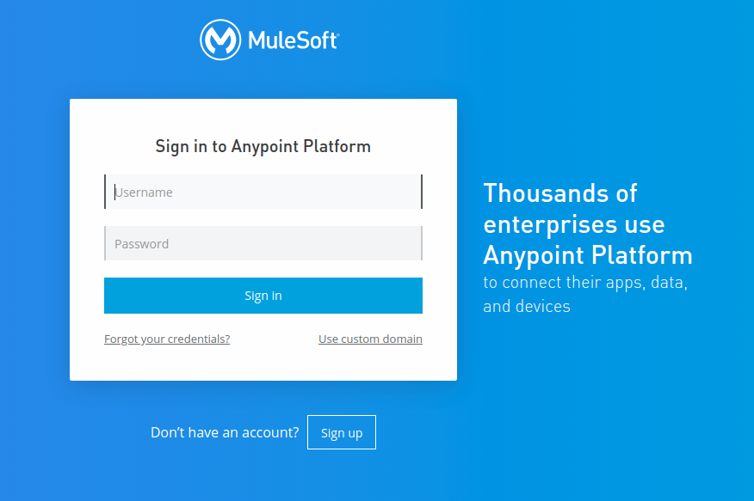

**Link** : <https://anypoint.mulesoft.com/login/>

**Username** : gok-esb-admin

**Password** : Ce**********

### Landing Page

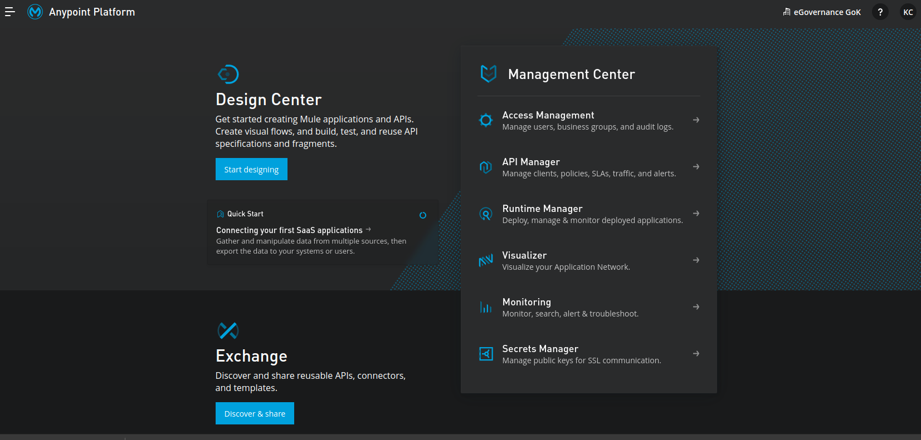

### Runtime Landing Page

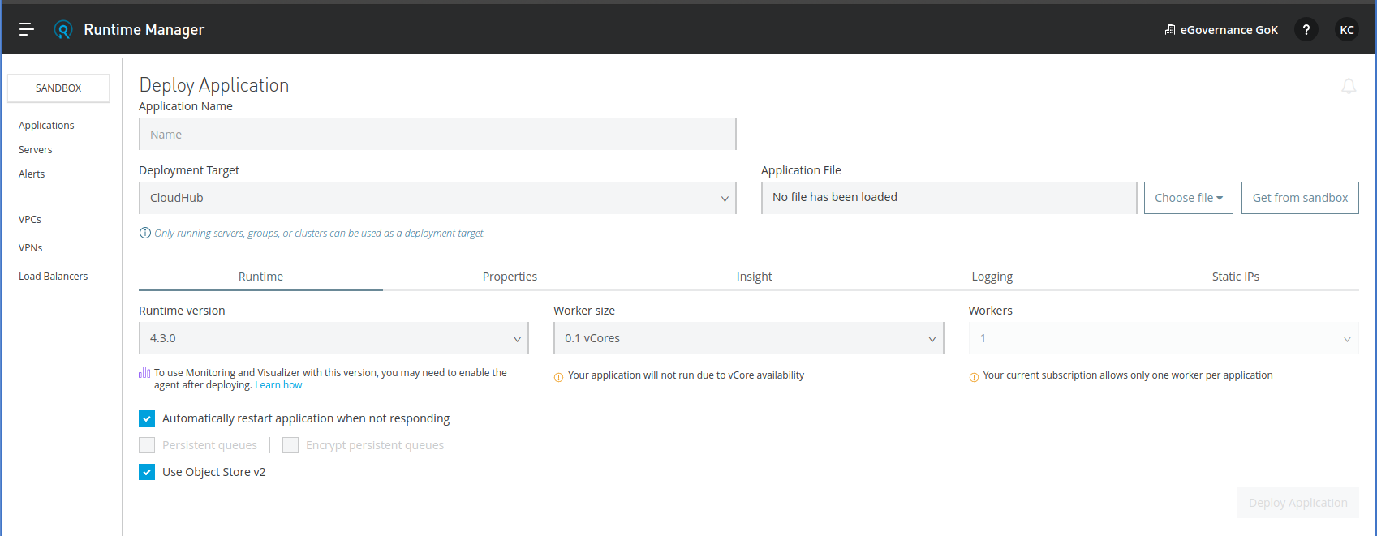

## References

### <https://docs.mulesoft.com/runtime-manager/>

### 